Only questions LEC (1-5) /Discrete Mathematics

**LEC 2**

EX_1: The set V of all vowels in the English alphabet can be written as V = {a, e, i, o, u}.

EX_2: The set O of odd positive integers less than 10 can be expressed by O = {1, 3, 5, 7, 9}.

EX_ 3: Although sets are usually used to group together elements with common properties, there is nothing that prevents a set from having seemingly unrelated elements. For instance, {a, 2, Fred, New Jersey} is the set containing the four elements a, 2, Fred, and New Jersey. Sometimes the roster method is used to describe a set without listing all its members. Some members of the set are listed, and then ellipses (. . .) are used when the general pattern of the elements is obvious.

EX_4 The set of positive integers less than 100 can be denoted by {1, 2, 3, . . ., 99}.

EX_5: The set {N, Z, Q, R} is a set containing four elements, each of which is a set. The four elements of this set are N, the set of natural numbers; Z, the set of integers; Q, the set of rational numbers; and R, the set of real numbers.

EX_6: The sets {1, 3, 5} and {3, 5, 1} are equal, because they have the same elements.

EX_7: Draw a Venn diagram that represents V, the set of vowels in the English alphabet.

EX_10: Let A be the set of odd positive integers less than 10. Then |A| =?

EX_11: Let S be the set of letters in the English alphabet. Then |S| =?

EX_12: Because the null set has no elements, it follows that |∅| =?

EX_13: The set of positive integers is infinite.

EX_14: What is the power set of the set {0, 1, 2}?

EX_15: What is the power set of the empty set? What is the power set of the set {∅}?

EX_16: Let A represent the set of all students at a university, and let B represent the set of all courses offered at the university. What is the Cartesian product A × B and how can it be used?

EX_17: What is the Cartesian product of A = {1, 2} and B = {a, b, c}?

EX_18: Show that the Cartesian product B × A is not equal to the Cartesian product A × B, where A and B sets are as in Example 17.

EX_19: The union of the sets {1, 3, 5} and {1, 2, 3} is the set {1, 2, 3, 5}; that is, {1, 3, 5} ∪ {1, 2, 3} =

EX_20: The intersection of the sets {1, 3, 5} and {1, 2, 3} is the set {1, 3}; that is, {1, 3, 5} ∩ {1, 2, 3} =

EX_21: Let A = {1, 3, 5, 7, 9} and B = {2, 4, 6, 8, 10}. Because A ∩ B = ∅, A and B are disjoint.

EX_22: The difference of {1, 3, 5} and {1, 2, 3} is the set {5}; that is, {1, 3, 5} − {1, 2, 3} = {5}. This is different from the difference of {1, 2, 3} and {1, 3, 5}, which is the set {2}.

EX_23: Let A = {a, e, i, o, u} (where the universal set is the set of letters of the English alphabet). Then 𝑨 = ?

EX_24: Let A be the set of positive integers greater than 10 (with universal set the set of all positive integers). Then 𝑨 = ?

EX_25: Let A = {0, 2, 4, 6, 8}, B = {0, 1, 2, 3, 4}, and C = {0, 3, 6, 9}. What are A ∪ B ∪ C and A ∩ B ∩ C?

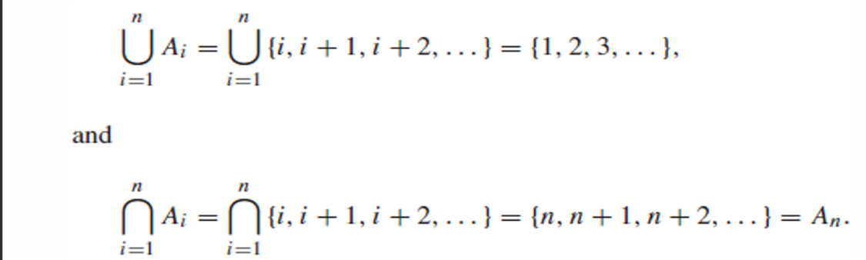EX_26: For i = 1, 2, . . ., let Ai = {i, i + 1, i + 2, . . .}. Then,

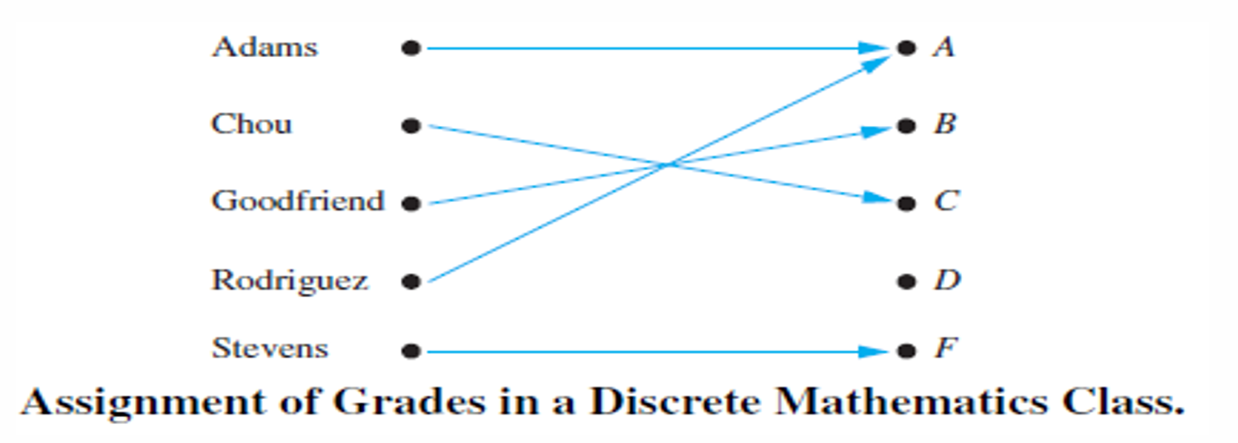EX_27: Suppose that each student in a discrete mathematics class is assigned a letter grade from the set {A, B, C, D, F}. And suppose that the grades are A for Adams, C for Chou, B for Goodfriend, A for Rodriguez, and F for Stevens. This assignment of grades is illustrated the Figure below:

EX_28: What are the domain, codomain, and range of the function that assigns grades to students in EX_27?

EX_29: Let R be the relation with ordered pairs (Abdul, 22), (Brenda, 24), (Carla, 21), (Desire, 22), (Eddie, 24), and (Felicia, 22). Here each pair consists of a graduate student and this student’s age. Specify a function determined by this relation.

EX_30 Let f: Z → Z assign the square of an integer to this integer. Then, f (x) =𝑥2, where the domain of f is the set of all integers, the codomain off is the set of all integers, and the range of f is the set of all integers that are perfect squares, namely, {0, 1, 4, 9, . . .}.

**LEC3**

EX_1: Let f1 and f2 be functions from R to R such that f1(x) = 𝑥2and f2(x) = x − 𝑥2. What are the functions f1 + f2 and f1f2?

EX_2: Determine whether the function f from {a, b, c, d} to {1, 2, 3, 4, 5} with f (a) = 4, f(b) = 5, f (c) = 1, and f (d) = 3 is one-to-one.

EX_3: Determine whether the function f (x) =𝑋2 from the set of integers to the set of integers is one-to-one.

EX_4: Let f be the function from {a, b, c, d} to {1, 2, 3} defined by f (a) = 3, f (b) = 2, f (c) = 1 , and f (d) = 3. Is f an onto function?

EX_5 : Is the function f (x) =𝑋2 from the set of integers to the set of integers onto?

EX_6: Let f be the function from {a, b, c} to {1, 2, 3} such that f (a) = 2, f (b) = 3, and f (c) = 1. is f invertible, and if it is, what is its inverse?

EX_7: Let f be the function from R to R with f (x) =𝑋2. Is f invertible?

EX_9: Let A = {0, 1, 2} and B = {a, b}. Then {(0, a), (0, b), (1, a), (2, b)} is a relation from A to B. This means, for instance, that 0 R a, but that 1 b.

EX_10: Let A be the set {1, 2, 3, 4}. Which ordered pairs are in the relation R = {(a, b) | a divides b}?

EX_11: Consider these relations on the set of integers:

R1 = {(a, b) | a ≤ b},

R2 = {(a, b) | a > b},

R3 = {(a, b) | a = b or a = −b},

R4 = {(a, b) | a = b},

R5 = {(a, b) | a = b + 1},

R6 = {(a, b) | a + b ≤ 3}.

EX_12: Consider the following relations on {1, 2, 3, 4}:

R1 = {(1, 1), (1, 2), (2, 1), (2, 2), (3, 4), (4, 1), (4, 4)},

R2 = {(1, 1), (1, 2), (2, 1)},

R3 = {(1, 1), (1, 2), (1, 4), (2, 1), (2, 2), (3, 3), (4, 1), (4, 4)},

R4 = {(2, 1), (3, 1), (3, 2), (4, 1), (4, 2), (4, 3)},

R5 = {(1, 1), (1, 2), (1, 3), (1, 4), (2, 2), (2, 3), (2, 4), (3, 3), (3, 4), (4, 4)},

R6 = {(3, 4)}.

Which of these relations are reflexive?

EX_13: Which of the relations from Ex_11 are reflexive?

R1 = {(a, b) | a ≤ b},

R2 = {(a, b) | a > b},

R3 = {(a, b) | a = b or a = −b},

R4 = {(a, b) | a = b},

R5 = {(a, b) | a = b + 1},

R6 = {(a, b) | a + b ≤ 3}.

EX_14: Let A = {1, 2, 3} and B = {1, 2, 3, 4}. The relations R1 = {(1, 1), (2, 2), (3, 3)} and R2 = {(1, 1), (1, 2), (1, 3), (1, 4)} can be combined to obtain:

R1 ∪ R2 =

R1 ∩ R2 =

R1 − R2 =

R2 − R1 =

**LEC 4**

EX_1: Consider the following four statements:

(i) Ice floats in water and 2 + 2 = 4. (iii) China is in Europe and 2 + 2 = 4.

(ii) Ice floats in water and 2 + 2 = 5. (iv) China is in Europe and 2 + 2 = 5.

EX_2: Consider the following four statements

(i) Ice floats in water or 2 + 2 = 4. (ii) Ice floats in water or 2 + 2 = 5.

(iii) China is in Europe or 2 + 2 = 4. (iv) China is in Europe or 2 + 2 = 5.

EX_3 Consider the following six statements: (a1) Ice floats in water. (a2) It is false that ice floats in water. (a3) Ice does not float in water. (b1) 2 + 2 =5 (b2) It is false that 2 + 2 = 5. (b3) 2 + 2 ≠5

P_1: Let p be “It is cold” and let q be “It is raining”. Give a simple verbal sentence which describes each of the following statements: (a) ￢p; (b) p ∧ q; (c) p ∨ q; (d) q ∨￢p.

P_2: Find the truth table of ￢p ∧ q.

P_3: Show that the propositions ￢(p ∧ q) and ￢p ∨￢q are logically equivalent.

EX_5: Show that p ∨ (q ∧ r) and (p ∨ q) ∧ (p ∨ r) are logically equivalent

EX_4: Let p be the statement “Maria learns discrete mathematics” and q the statement “Maria will find a good job.” Express the statement p → q as a statement in English.

EX_6: What is the value of the variable x after the statement if 2 + 2 = 4 then x := x + 1 if x = 0 before this statement is encountered? (The symbol: = stands for assignment. The statement x := x + 1 means the assignment of the value of x + 1 to x.)

**LEC 5**

EX_1: Let p be the statement “Maria learns discrete mathematics” and q the statement “Maria will find a good job.” Express the statement p → q as a statement in English.

EX_2: A. the statement , “If Juan has a smartphone, then 2 + 3 = 5” is true from the definition of a conditional statement, because its conclusion is true. B. “If Juan has a smartphone, then 2 + 3 = 6” is False C. “If Juan has a smartphone, then 2 + 3 = 6” is true if Juan does not have a smartphone, even though 2 + 3 = 6 is false.

EX_3: What is the value of the variable x after the statement if 2 + 2 = 4 then x := x + 1 if x = 0 before this statement is encountered? (The symbol := stands for assignment. The statement x := x + 1 means the assignment of the value of x + 1 to x.)

EX_4: State the converse, contrapositive, and inverse of each of these conditional statements. a) If it snows tonight, then I will stay at home. b) I go to the beach whenever it is a sunny summer day. c) When I stay up late, it is necessary that I sleep until noon.

EX_ 5: Consider the conditional proposition p → q. The simple propositions q → p, ￢p → ￢q and ￢q → ￢p are called, respectively, the converse, inverse, and contrapositive of the conditional p → q. Which if any of these propositions are logically equivalent to p → q?

EX_6: Let p be the statement “You can take the flight,” and let q be the statement “You buy a ticket.” Then p ↔ q is the statement: “You can take the flight if and only if you buy a ticket.”

EX_7: Construct the truth table of the compound proposition: (p ∨￢q) → (p ∧ q).

*(The slide is a personal effort and not from any professor.)